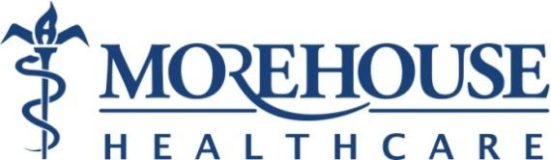

Photo Consent Form

_____ I consent to being photographed and/or videotaped before, during and after treatment. These images will become a permanent part of my medical record.
I give my permission for these images to also be used for (please initial):
_____ educational purposes
_____ scientific publications
_____ demonstration to other prospective patients
_____ practice website/internet/program Facebook page
_____ none of the above/ I do not give my permission
I give permission for use of photos of my (please initial):
_____ face
_____ body
_____ breasts
_____ none of the above/ I do not give my permission

I grant Morehouse Healthcare and Morehouse School of Medicine to edit, use and/or disclose any such photographs or recordings for the purposes outlined above. I understand that I may withdraw my consent to the above listed at any time.

Patient Name: ___________________________________ Date: ___________________
Patient Signature: _______________________________________________________________
Witness Name: __________________________________ Date: ___________________
Witness Signature: ______________________________________________________________

